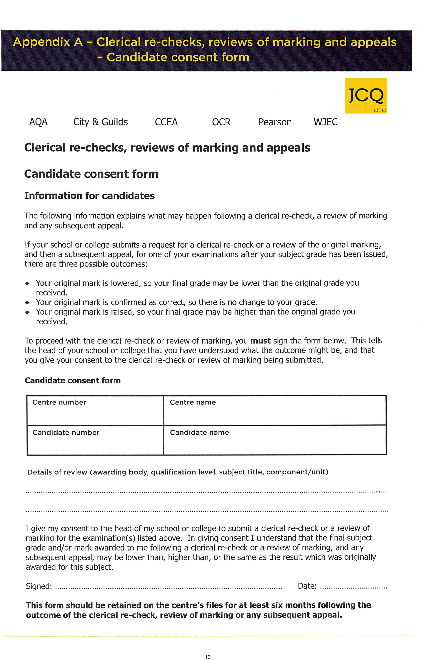

Blessed Edward Oldcorne Catholic College

24415